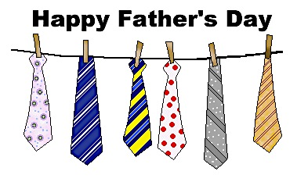

WELCOME TO THE BLACK OLIVE RESTAURANT

FATHER’S DAY BREAKFAST SPECIALS

ALL SPECIALS INCLUDE HOT TEA OR COFFEE

1. COUNTRY EGGS BENEDICT……..……………...……………...............…$8.99

WITH POACHED EGGS, CANADIAN BACON, SERVED ON TOP OF AN ENGLISH MUFFIN, TOPPED WITH SAUSAGE GRAVY, SERVED WITH HOME FRIES

1. FRENCH CONNECTION………..………….........………............…..……...$9.99

WITH RAISIN FRENCH TOAST, (2) SCRAMBLED EGGS, (2) SAUSAGE LINKS, HOMEFRIES AND A CUP OF CHIPPED BEEF

1. HAM STEAK AND EGGS…….…………………….………………………$10.99

TWO EGGS (ANY STYLE) WITH HAM STEAK, HOME FRIES AND CHOICE OF TOAST

1. FATHER’S DAY OMELETTE…………………………..…….……………..$8.25

WITH FRESH SPINACH, BACON, HAM, SAUSAGE, GREEN PEPPERS, RED ONION & AMERICAN CHEESE. SERVED WITH HOME FRIES, TOAST AND JELLY

1. KING OMELETTE………..……………………...……...……......................$10.99

DICED PRIME RIB, ROASTED PEPPERS, FRIED ONIONS, AND CHEDDAR CHEESE SERVED WITH HOME FRIES, TOAST AND JELLY

1. MARYLAND SEAFOOD OMELETTE…..…...……...........................…..…..$8.99

SHRIMP, CRABMEAT AND ASPARAGUS WITH SWISS CHEESE SERVED WITH HOME FRIES, TOAST AND JELLY

1. TURKEY BACON, EGG, AND CHEESE…………………………….……..$7.99

TURKEY BACON, FRIED EGG, AMERICAN CHEESE, ON A TOASTED BAGEL SERVED WITH HOME FRIES



THANK YOU FOR DINING WITH US

HAPPY FATHER’S DAY